Experimental Design
a) a learning by teaching (LBT) version in which students taught Betty,
b) a self-regulated learning by teaching (SRL) version in which students taught Betty and received metacognitive prompts from Betty, and
c) an intelligent coaching system (ICS) version in which students created a map for themselves with guidance from the mentor agent. T

Results
Students who taught developed more complete and interconnected concept maps than students who created maps for themselves. The differences in map scores are statistically significant (SRL > LBT, ICS; LBT > ICS; p < 0.05) in the main phase, and the difference between SRL and ICS persisted during the transfer phase
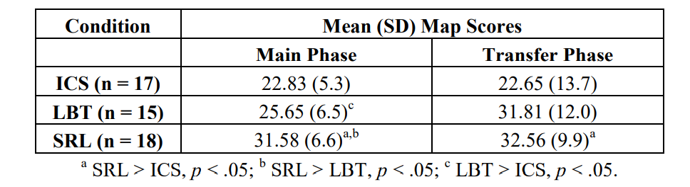
We found that students who generated better concept maps used balanced learning strategies: they read resources, built and edited their concept maps, asked queries to probe the correctness of their maps, and used quiz questions in equal measure to learn about the domain. On the other hand, students who generated low scoring concept maps adopted a myopic learning strategy that overly focused on getting their quiz answers correct. They relied mostly on the quiz questions, and did not seem to read resources or probe their maps by asking queries very often.

MODEL SELECTION
To this end, we found the hidden Markov models (HMMs) to be the most appropriate, as they allow us to identify some of the students’ general behavior patterns from sequences of their interactions with the system.

Analyzing Behaviour:
1. devise a logging system that records student interactions with the system;
2. perform data cleaning by parsing the generated log files and splicing the information into desired activity sequence data that will form the input to the HMM generating algorithm
3. construct the HMM 129 models;
4. interpret generated models as student learning behaviors and compare models across conditions.

In the transfer phase when the students operate in a common environment, we see that the differences become smaller. In all three groups, we see a great spike in the number of resource accesses relative to the main phase. At the same time, we observe a decrease in the occurrence of some of the higher-level patterns. This may be due to the students learning about a new domain with a simpler expert map that contains fewer interdependences between concepts, and being given few sessions than in the main phase (five versus seven). This also could be due to the students internalizing the reasoning mechanism, therefore, a reduced need to perform such activities in the transfer phase

Conclusion:
They have helped us establish that learning by teaching provides better opportunities for learning even among 5th grade students. Further, metacognitive prompts while learning enable students to develop higher level learning strategies that they retain even when the feedback prompts are removed

